CHAPTER THREE
SYSTEM DESIGN AND IMPLEMENTATION
3.1 Introduction
This chapter describes the methodology adopted in developing the Student Clearance Management System. It presents the overall system design, architecture, database structure, and implementation strategy. It also details the technologies employed, the software development methodology adopted, and the system’s operational workflows. The chapter concludes with a discussion of the user interface design and system functionalities, supported by relevant screenshots illustrating different components of the system.

3.2 System Development Methodology
3.2.1 Development Approach
The system was developed using the Agile Software Development Methodology, specifically following the Scrum framework. This approach enabled iterative and incremental development, ensuring continuous collaboration between the development team and stakeholders. Each feature was developed, tested, and reviewed within short, manageable sprints.
Key Agile Principles Applied:
- Iterative Development: Functional modules were completed in 2-week sprints.
- User-Centered Design: Continuous feedback was obtained from departmental officers and students.
- Test-Driven Development: Each sprint included automated and manual tests.
- Continuous Integration: Code was frequently integrated and tested to prevent defects.
- Comprehensive Documentation: Technical and user documentation was maintained throughout the process.
(See Figure 3.1 for the adopted Agile development cycle.)
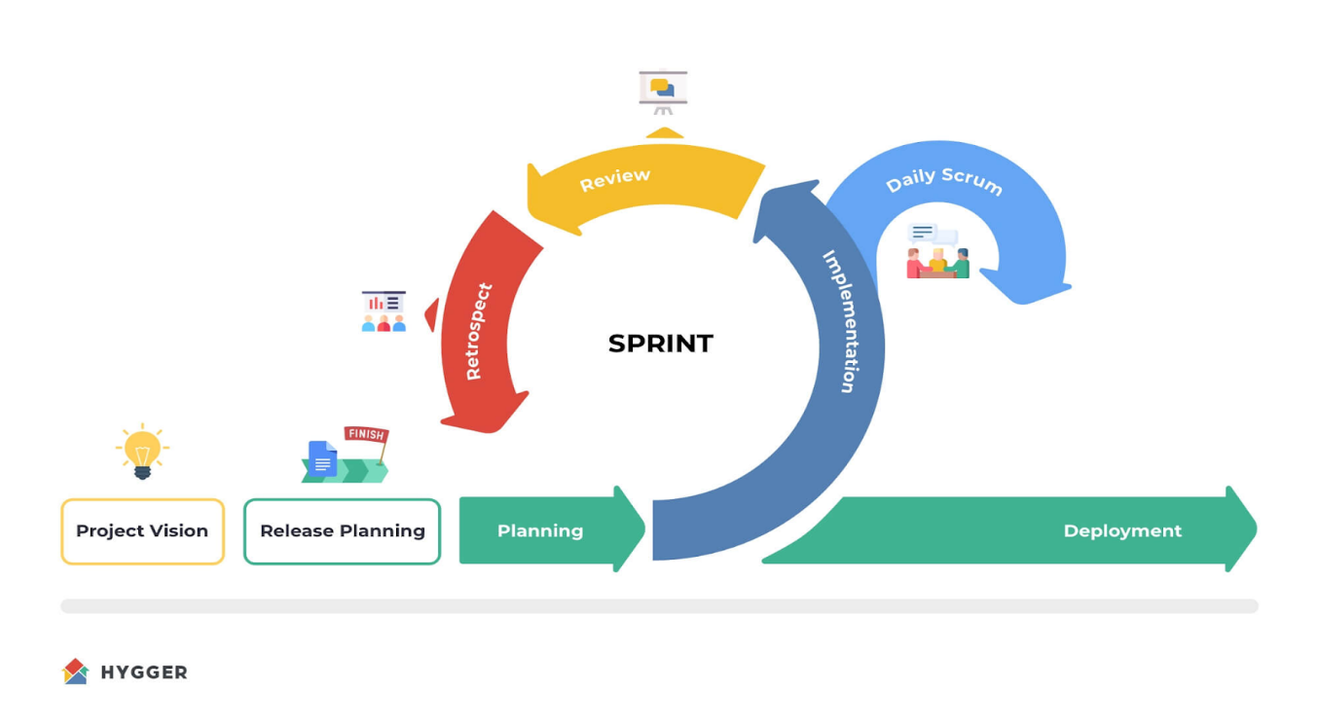
Figure 3.1: Agile Scrum Development Cycle
3.2.2 System Development Life Cycle (SDLC)
The system development followed the Software Development Life Cycle (SDLC) framework, which includes several well-defined stages:
- Requirements Analysis and Planning (2 weeks):
Stakeholder interviews, system requirement specification, and feasibility study were conducted.
- System Design and Architecture (3 weeks):
Database schema, component diagram, and UI mockups were designed using Figma and Lucidchart.
- Implementation and Development (8 weeks):
Backend APIs were built with Express.js and MongoDB, while the frontend was implemented using React.js.
- Testing and Quality Assurance (2 weeks):
Unit, integration, and acceptance testing were carried out to ensure reliability.
- Deployment and Maintenance (1 week):
The system was deployed to a live server with continuous support for bug fixes and updates.
Figure 3.2: SDLC Phases for the Student Clearance Management System

3.3 System Architecture
3.3.1 Overall System Architecture
The system is designed using a three-tier architecture — presentation, application, and data tiers — to ensure scalability, maintainability, and efficient data management.
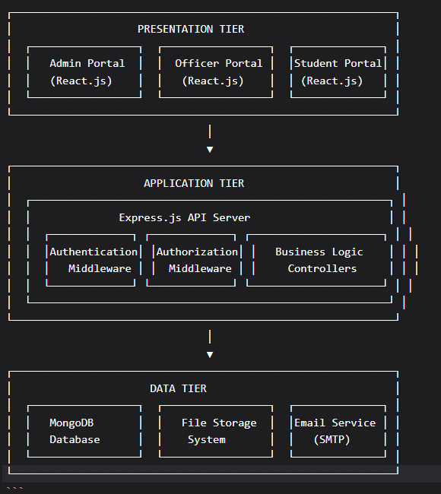
Figure 3.3: Three-Tier System Architecture Diagram
Presentation Tier → Application Tier → Data Tier
This structure separates the front-end user interface (React.js), the application logic (Node.js/Express), and the database management (MongoDB).

3.3.2 Component Architecture
3.3.2.1 Frontend Architecture (React.js)
The front-end is modular, ensuring reusability and maintainability. The application uses Redux Toolkit for centralized state management and React Hook Form for efficient form validation.
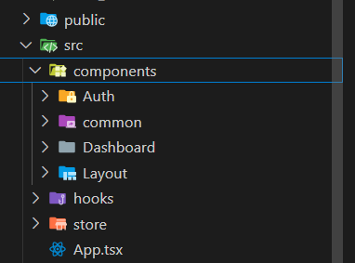
Figure 3.4: Frontend Component Structure
Key components include:
- Authentication: Login and protected routes.
- Dashboard: Student, Officer, and Admin dashboards.
- Common Components: Document viewer, loading spinner, and notification dropdown.
3.3.2.2 Backend Architecture (Node.js/Express)
The backend provides RESTful APIs for all operations. It manages authentication, file uploads, and database interactions.
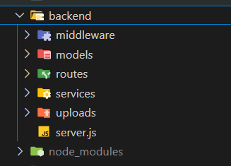
Figure 3.6: Backend Folder Structure

3.3.3 Technology Stack
Technology | Version | Layer | Purpose
React.js | 18.3.1 | Frontend | Dynamic UI
Node.js | 20.x | Backend | Server runtime
Express.js | 4.18.2 | Backend | API framework
MongoDB | 6.x | Database | Document-based storage
Redux Toolkit | 2.0.1 | Frontend | State management
Tailwind CSS | 3.4.1 | Frontend | Styling
Mongoose | 8.0.3 | Backend | ODM and schema validation

3.4 Database Design
3.4.1 Database Schema Design
The system uses MongoDB to manage data in a document-oriented format. The main collections include Users, ClearanceRequests, Documents, Departments, and Notifications.
Figure 3.7: Database Schema Diagram
Each collection enforces referential integrity using Mongoose relationships and validation rules such as unique email constraints and role-based access control.
3.4.2 Data Integrity and Validation
- Email uniqueness and password hashing are enforced.
- Automatic timestamps are generated for all documents.
- Cascade delete ensures cleanup of dependent records.

3.5 System Workflow Design
3.5.1 Clearance Request Workflow
The clearance process is sequential, moving from department to department until all approvals are obtained.
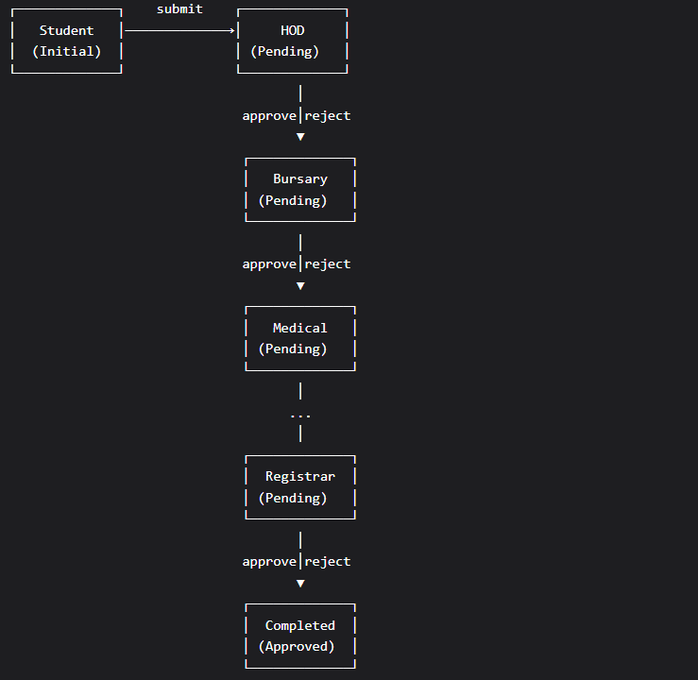 Figure 3.7: Clearance Workflow Diagram
The workflow includes the following stages:
Student → HOD → Bursary → Medical → Library → Faculty → Hostel → Alumni → Registrar → Completed
Each stage involves approval, rejection, or document re-submission, with automatic notifications to concerned officers.

3.5.2 Authentication and Authorization Workflow
User access is role-based, with JWT tokens for authentication. The authorization matrix ensures that each user role (Student, Officer, Admin) only accesses permissible modules.
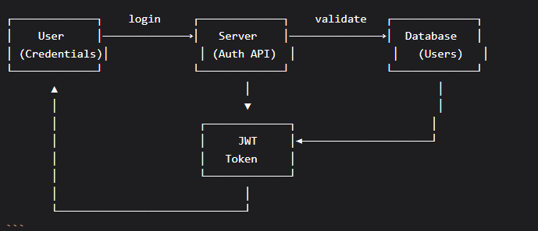
Figure 3.8: Authentication and Authorization Flow Diagram

3.6 User Interface Design
3.6.1 Design Principles
The interface follows modern usability standards:
- Responsiveness: Optimized for mobile, tablet, and desktop.
- Accessibility: WCAG 2.1 compliance.
- Consistency: Color and typography uniformity using Tailwind CSS.
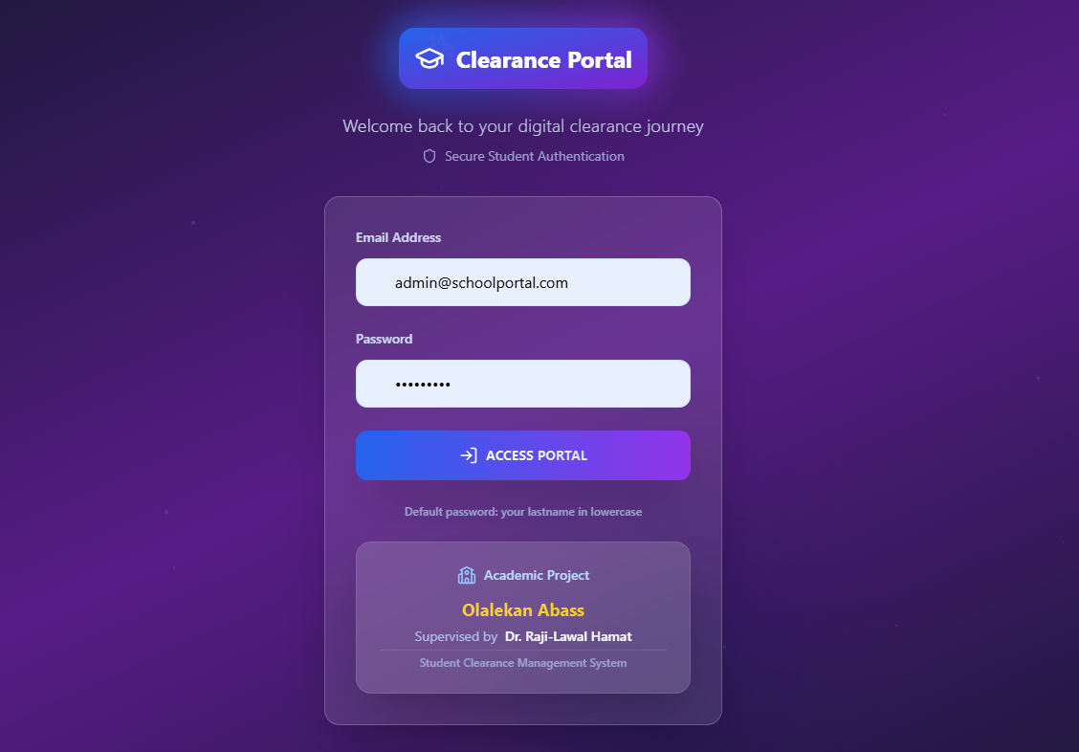 Figure 3.9: Login Interface
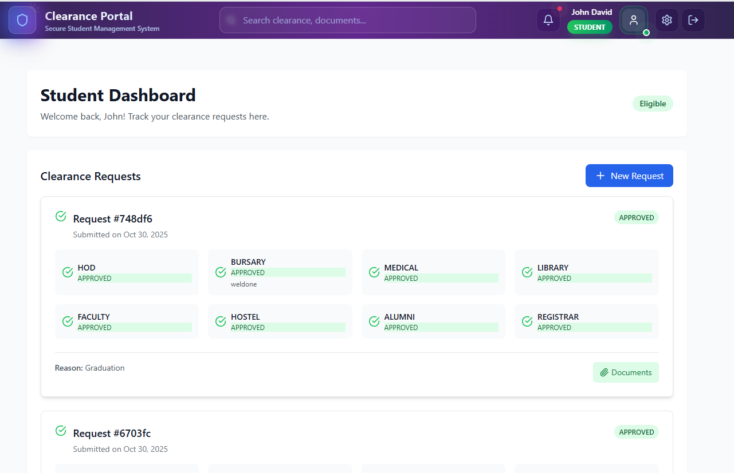 Figure 3.10: Student Dashboard Interface
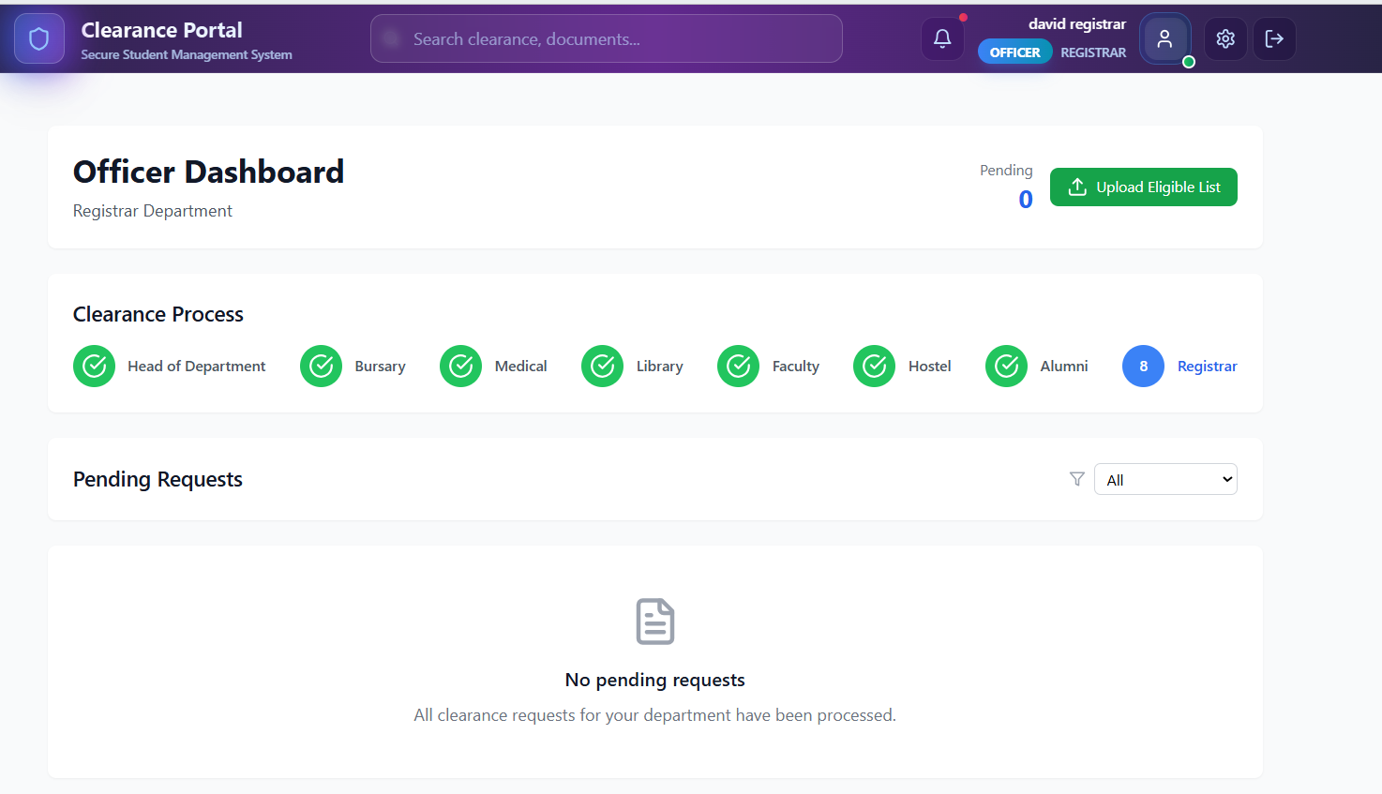
Figure 3.11: Officer Dashboard Interface
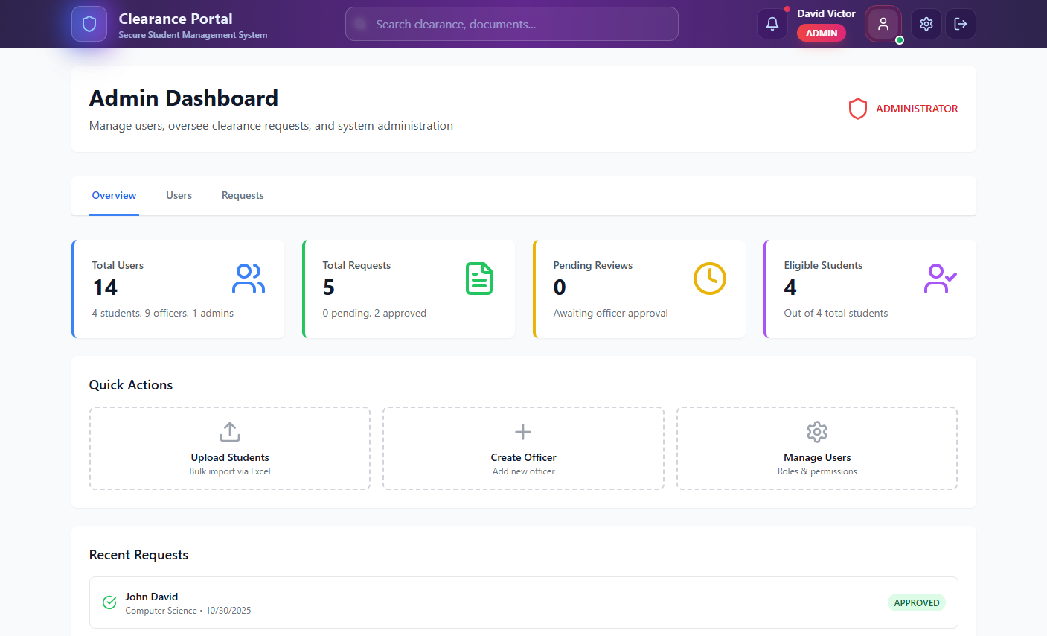 Figure 3.12: Admin Dashboard Interface

3.7 API Design and Implementation
The API follows RESTful principles and supports CRUD operations for users, clearance requests, departments, and notifications. Security is ensured through token-based authentication (JWT) and role-based authorization middleware.
3.8 File Upload and Document Management
The system allows students to upload required clearance documents securely. File validation ensures correct MIME types and size restrictions. Multer middleware handles the upload process, while files are stored in a structured directory.
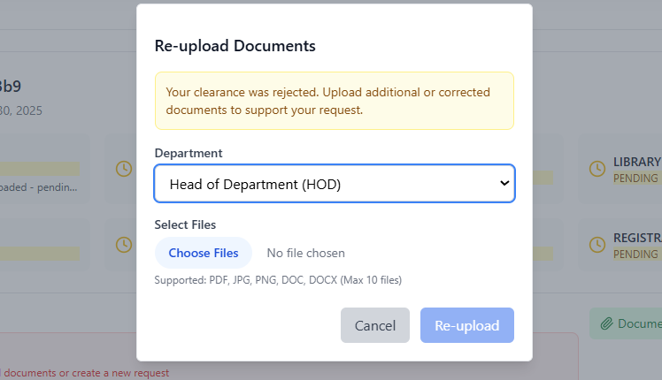 Figure 3.14: Document Upload Interface
3.9 Summary
This chapter has detailed the methodology and technical implementation of the Student Clearance Management System. It explained the Agile-based development process, system architecture, database schema, workflow, and user interface design. The system integrates secure authentication, responsive design, and efficient data handling to automate and streamline student clearance activities in academic institutions.

